EJERCICIOS DE INTEGRALES POR SUSTITUCION TRIGONOMETRICA

$$\int{\frac{\sqrt{4-X^{2}}}{X}} dx$$
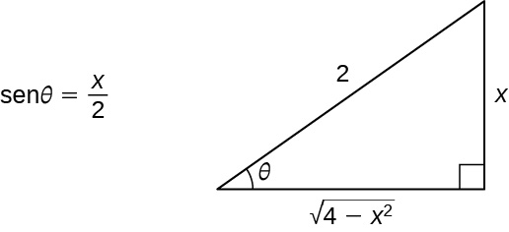

A² = 4 b² =1
A=2 b= 1
CAMBIO X = $\frac{2}{1}$ SEN Z dx = 2. Cosz dz $\sqrt{} =2.cosz$

Sustituyendo en la integral$\int{\frac{2cosz . 2 cosz dz}{2.senz}}$ =$\int{\frac{2.\cos^{2}z}{senz}}$dz = 2$\frac{\int{1-{sen}^{2}z}}{senz}dz$

=2.$\int{\frac{1}{senz}}$dz -2$\int{senzdz}$ = 2$\int{csczdz-2\int{senzdz}}$

2.Ln (cscz-ctgz) - (-cosz)

Devolviendo el cambio
X = $\frac{2}{1}$ SEN Z $\frac{X}{2}=Sen z= \frac{CO}{H}$

CSCZ= $\frac{1}{SENZ}$ = $\frac{H}{CO}$ Ctgz =$\frac{CA}{CO}$ COSZ = $\frac{CA}{H}$
ENTONCES
2.Ln ($\frac{2}{X}$ - $\frac{\sqrt{4-X^{2}}}{X}$) + 2 ($\frac{\sqrt{4 - X^{2}}}{2}) +C$ 2.Ln ($\frac{2}{X}$ - $\frac{\sqrt{4-X^{2}}}{X}$) + ($\frac{\sqrt{4 - X^{2}}}{}) +C$

